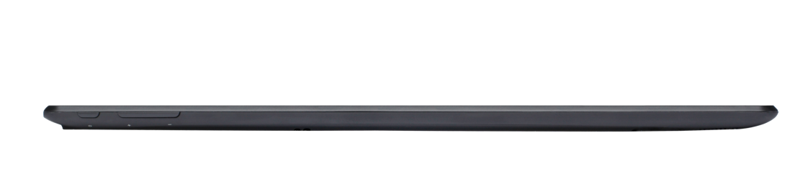
Closet

Bathroom
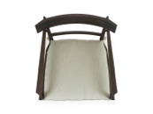













































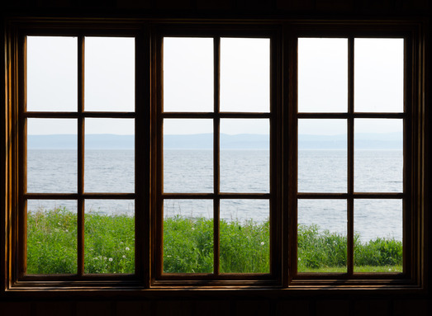

7 total rows
7 chairs in each row except last row
46 total chairs
Kitchen Area

